Exercise 6: Set Operator

In this practice, you write queries using the set operators.
Using the Set Operators

1) The HR department needs a list of department IDs for departments that do not contain
the job ID ST_CLERK. Use the set operators to create this report.

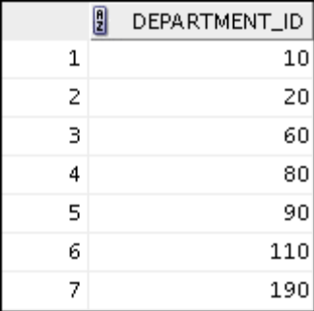
2) The HR department needs a list of countries that have no departments located in
them. Display the country ID and the name of the countries. Use the set operators to
create this report.
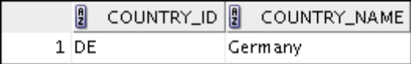
3) Produce a list of jobs for departments 10, 50, and 20, in that order. Display the job ID
and department ID by using the set operators.

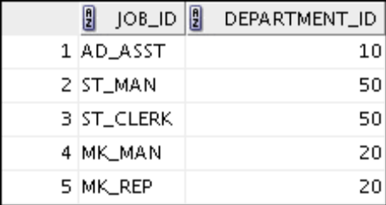

4) Create a report that lists the employee IDs and job IDs of those employees who
currently have a job title that is the same as their job title when they were initially
hired by the company (that is, they changed jobs, but have now gone back to doing
their original job).

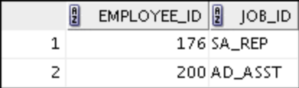

5) The HR department needs a report with the following specifications:
Last name and department ID of all employees from the EMPLOYEES table,
regardless of whether or not they belong to a department
Department ID and department name of all departments from the DEPARTMENTS
table, regardless of whether or not they have employees working in them
Write a compound query to accomplish this.

